

IEEE-Wiley Telecommunications eBooks Library

Delivered through the IEEE *Xplore*® Digital Library

# Keep up-to-date with the latest in telecommunications technology

Stay informed about the ever-evolving field of telecommunications with this collection of high-quality eBook titles from Wiley, delivered via the IEEE *Xplore* digital library. With over 360 titles dating back to 2007, this collection provides essential information on telecommunications and related fields with concentrated content applicable for students, researchers, and practicing engineers.  
  
Key Benefits:

▪Drive new ideas, designs, and applications with   
cutting-edge research

▪ Develop better solutions faster by understanding the   
technology landscape

▪ Accelerate innovation and patent development with convenient access to proven research all in one place

▪ Stay ahead of the technology curve with the latest information, authored by leaders in the field

▪ Increase productivity by reviewing previous research   
without having to reinvent the wheel

# Content Areas:

The collection of titles includes practical handbooks, introductory and advanced texts, reference works, and professional books with an emphasis on leading areas of research, such as:

# **IEEE-Wiley Telecommunications eBooks Library Quick Facts:**

Access to 360+ titles, with approximately   
15 new titles introduced each year

Subject matter focuses on telecommunications and related fields

Search by title, keyword, or subject

Backlist to 2007

Available as an add-on to existing subscriptions or as a stand-alone product:

Annual Subscription Option  
Provides leased access to current year   
eBook titles, plus leased access to the   
backlist of more than 360 titles.

Purchase Option with Perpetual Access*  
Provides perpetual access to current year eBook titles, plus perpetual access to the backlist of more than 360 titles. An option to expand the collection by purchasing new frontlist titles each year is also available.

* Perpetual access to the collection is offered via   
IEEE *Xplore*

Visit www.ieee.org/wiley-telecom for a complete list of titles included in the collection.

For a custom quote, please contact your IEEE Sales Representative.

▪ Antenna & Propagation

▪ Audio & Speech Processing & Broadcasting

▪ Communication System Security

▪ Communication Technology, Networks

▪ Mobile & Wireless Communications

▪ Networking & Broadcasting

▪ Optical Communications

▪ Satellite Communications

▪ Signal Processing & Analysis



# Subscribe Today

See how IEEE *Xplore* can help drive research and innovation.  
Visit www.ieee.org/wiley-telecom

IEEE *Xplore* Digital Library [www.ieee.org/ieeexplore](http://www.ieee.org/ieeexplore) Email: [onlinesupport@ieee.org](mailto:onlinesupport@ieee.org)



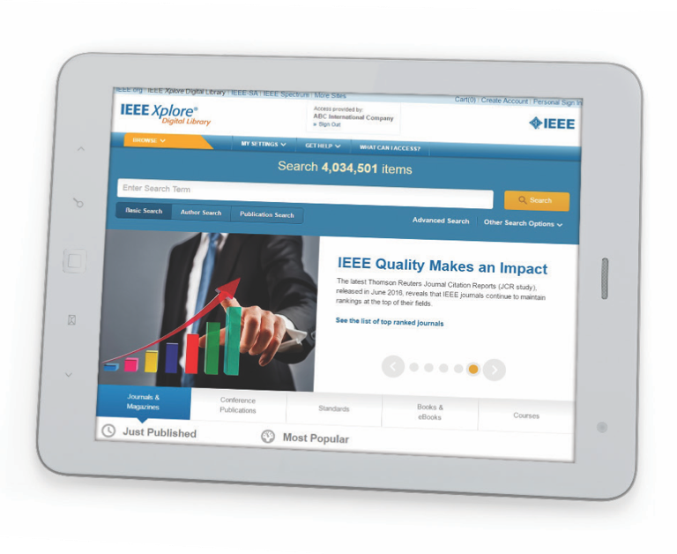

IEEE-Wiley Telecommunications eBooks Library

Delivered through the IEEE *Xplore®* Digital Library

# Subscribe Today

See how IEEE *Xplore* can help drive research and innovation.  
Visit www.ieee.org/wiley-telecom

IEEE *Xplore* Digital Library [www.ieee.org/ieeexplore](http://www.ieee.org/ieeexplore) Email: [onlinesupport@ieee.org](mailto:onlinesupport@ieee.org)

# Access respected research and trusted technology research that generates results

IEEE *Xplore* includes top-ranked journals and technology research that is cited in patents three times more often than any other publisher. With more than four million full-text articles and papers, IEEE *Xplore* is your gateway to more than 30% of the world’s current literature in electrical engineering, electronics, and computer science.

# Find relevant research faster with powerful, easy-to-use search tools

The IEEE-Wiley Telecommunications eBooks Library is searchable via IEEE *Xplore* by title, keyword, or subject, which will return all titles and eBook chapters relevant to your query. Keyword or subject searching allows users to find the topic of interest easily at the chapter level, while a title search allows users to view an eBook title’s home page with table of contents linking to full-text chapters.

# IEEE *Xplore* also provides:

▪ More than four million documents in  
full-text PDF format, with more than two million in a robust, dynamic HTML format

▪ Multiple authentication options for   
on-site, remote, and mobile users

▪ INSPEC® abstract and citation records

▪ New mobile-friendly design

▪ Daily content updates

Phone: +1 800 701 IEEE (4333) (USA/Canada)

+1 732 981 0060 (worldwide)

Email: onlinesupport@ieee.org

16-PIM-164ee A4 09/17